**Worksheet C**

AI spawn on key press (Couldn’t manage to get them to spawn after death)

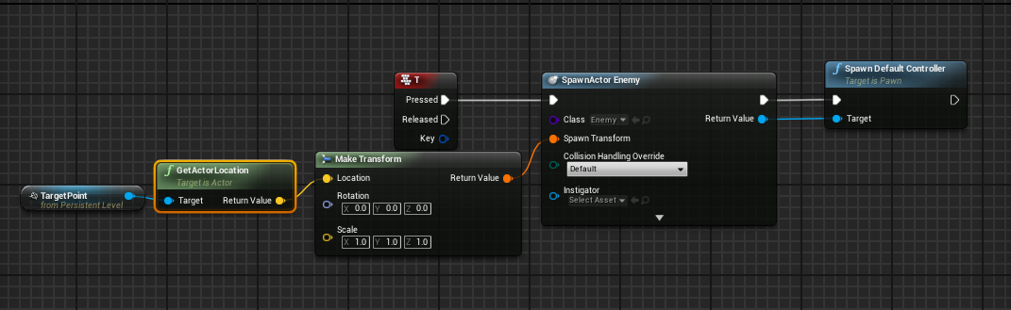

AI follow player when seen and dies when hit by projectile

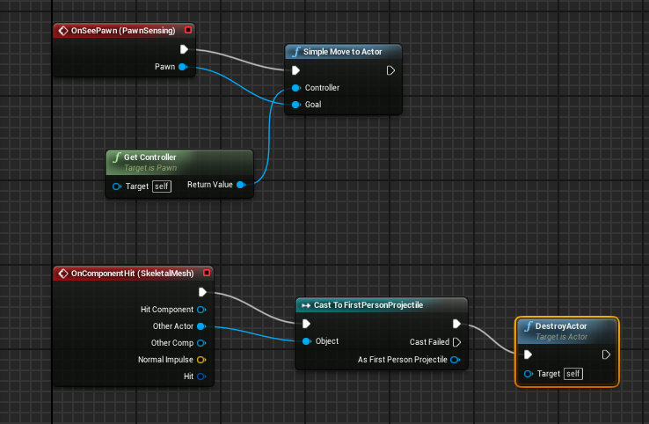

Grenade Launcher Blueprint

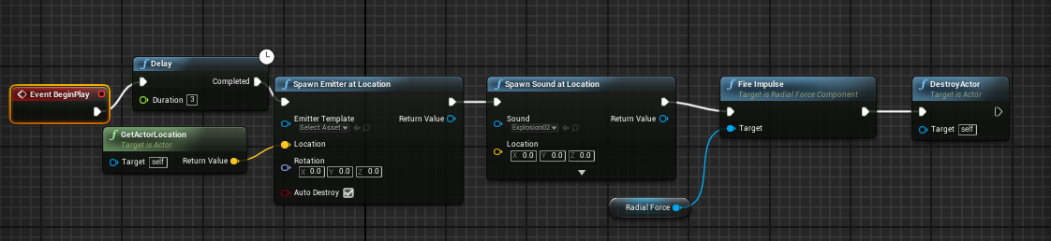

Player dies when touched by AI

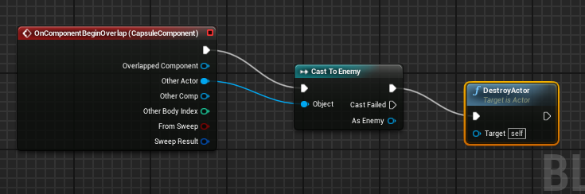

Ray Casting

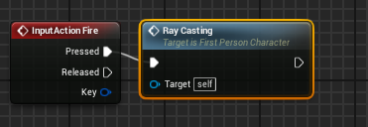

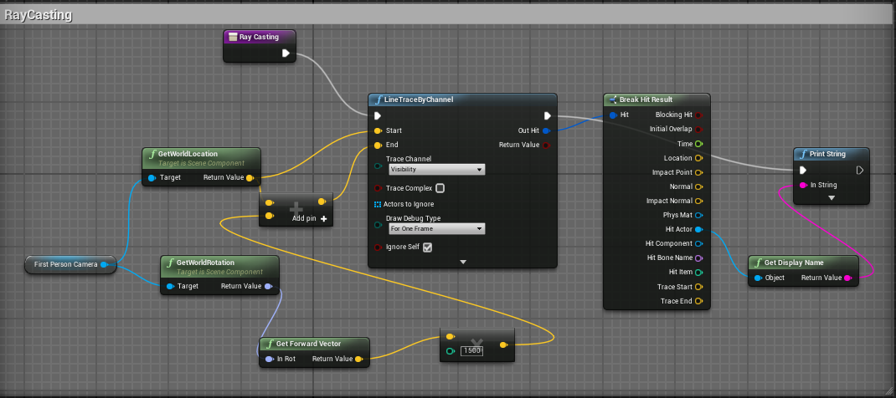

Switching Weapons

